**Preparing for the 3+ Branch Workflow - Developers**

**Create a Fork of the Official Repository**

Navigate to the URL for the official repository on GitHub, and then click the **Fork** button:

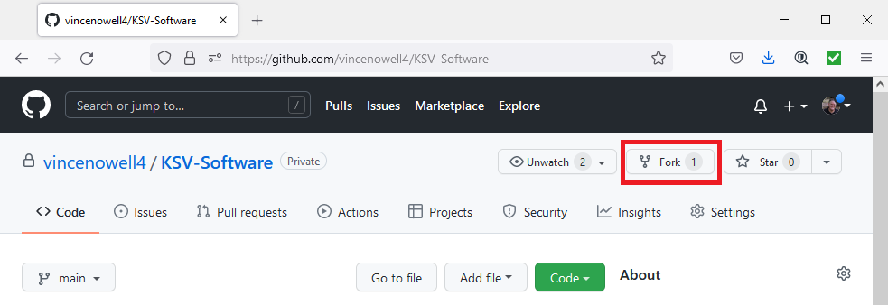

A dialog may open, giving you options of where to fork the official repository to; if it does, choose one of the options. Otherwise, a new repository will be created under your GitHub account. Make note of the URL for this repository; you will need it for the next step.

**Cloning the Fork**

You can now clone this fork to your PC. Open Git Bash and use the 'cd' command to get to your repos folder. Alternatively, navigate to your repos folder on your PC using File Explorer (typically, this folder would be in this path: c:\Users*yourusername*\source\repos), then right click and then click **Git Bash Here**. Once you are in the repos folder in Git Bash, type:

git clone [https://github.com/*your-github-user*/*your-team-name*.git](https://github.com/your-github-user/your-team-name.git)

NOTE: The URL after 'git clone' is the one you created in the first step.

The process of creating the clone will also set your "origin" pointer to your fork of the official repository; you can check this by changing to the newly created folder in your repo folder and using 'git remote' to see where origin is pointing to:

cd *your-team-name*/

git remote --verbose

Now, get the dev branch from your fork on GitHub, and switch to it with the 'git checkout' command:

git fetch origin dev

git checkout dev

**Create an upstream reference**

The last thing to do in preparation to do the 3+ Branch Workflow is to create an upstream reference. This is a pointer to the official repository on GitHub, which you will need to get updates to the official main and dev branches. To create this reference, type:

git remote add upstream [https://github.com/*project-maintainers-account*/*your-team-name*.git](https://github.com/project-maintainers-account/your-team-name.git)

NOTE: The URL after 'upstream' is the URL for the official repository, not your fork URL. You can check all your remotes like this:

git remote --verbose

This should show you a list that includes your fork of the official repository (origin) as well as the pointer to the official repository (upstream).

You are now ready to start working on a story; see the document **Workflow for Working on a Story** for details on that process.